**Project 2: Simple Queries – Reading from a table**   
**Due Date: Wednesday, 10/5/2021 by 11:59 pm**

Make sure to read all of the following instructions before beginning.  
You will usethe[**World Product Company (WPC) Database**](https://iu.instructure.com/courses/2013459/files/123570968?wrap=1) (under the Resources tab).

* Sources:
  + Lecture [Three Part 1](https://iu.instructure.com/courses/2013459/files/123570967?wrap=1) and [Part 3](https://iu.instructure.com/courses/2013459/files/123570990?wrap=1)
  + Internet : <http://www.w3schools.com/sql/default.asp>
* Save each query with the provided name by each query question.
* Save your work as **LastName_Project2** before submitting it.

**Important Note:** Remember submit the file ending with the extension **.accdb** and not your backup file.

**NOTE:** How to create a simple query platform to apply SQL statements(Recording will be provided by 9/4/2021)

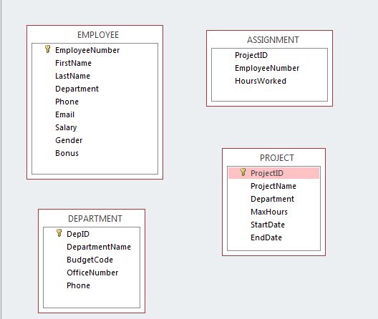

Image1: Four tables and their fields

Query Problems:

1. Display all records from the Assignment table except Project Id 1100, and 1400?

**Save the query as Q1ProjectIDs**

1. Display Project Id with their starting and ending dates where the starting date is after 10-Aug-05?

**Save the query as Q2StartEnd**

1. Display last name, first names with their phone numbers whose first names are “Tom” and “Richard”?

**Save your query as Q3PhoneNumbers**

1. Display all the employees’ numbers with their salaries if their salaries less than 9,000?

**Save your query as Q4LessThan**

1. Display Projects with maximum hours between 120 and 140

**Save your query as Q5MaxBetween**

1. Find the total number of Maximum Hours on project 1200.

**Save your query as Q6Total**

1. Find the largest MaxHours for projects.

**Save your query as Q7MaxHourProject**

1. Find the total number of hours worked for employee number 6 and display his/her income if he/she earns $12 per hour.

***Note:****You will calculate his/her payment as if the payment is 12 dollars per hour.*

*You may find the sample query for how to calculate is in the lecture 3 slides*

**Save your query as Q8TotalHours6**

1. Find how many projects Finance department has?

**Save your query as Q9FinanceProjects**

1. Find how many employees don't have a phone number yet.

**Save your query as Q10NoPhone**

**REQUIREMENTS: Check list**

1. Each query must be correctly implemented and must run successfully. (-2 for each)
2. All the queries must be saved in your database with the names that all have been provided above (-5)

3. Your DB should include only the assigned queries, No extra queries or files on the DB (-5 points)